
School: ............................................................................................................. Campus: ....................................................... Academic Year: ...................... Subject Name: ........................................................... Subject Code: ..........................
Semester: ............... Program: ........................................ Branch: ......................... Specialization: .......................... Date: .....................................
(Learning by Doing and Discovery)
* Coding Phase: Pseudo Code / Flow Chart / Algorithm
ALGORITHM:
- Install & set up MetaMask wallet in your browser.
- Switch network to Sepolia Testnet in MetaMask.
- Get free test ETH from a Sepolia faucet.
- Check balance in MetaMask after receiving test ETH.
- Send test ETH to another wallet address.
- Confirm transaction on Sepolia Etherscan.

* Softwares used
- MetaMask Wallet
- Brave Web Browser
- Sepolia Testnet Faucet
- Sepolia Etherscan

Applied and Action Learning

* Implementation Phase: Final Output (no error)
Go to MetaMask wallet choose the testnet and select sepolia testnet
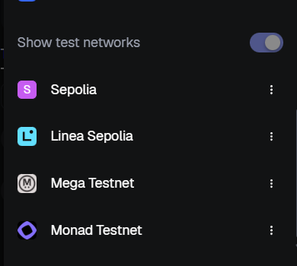
Then go to sepolia faucet cloud to faucet som sepolia testnet
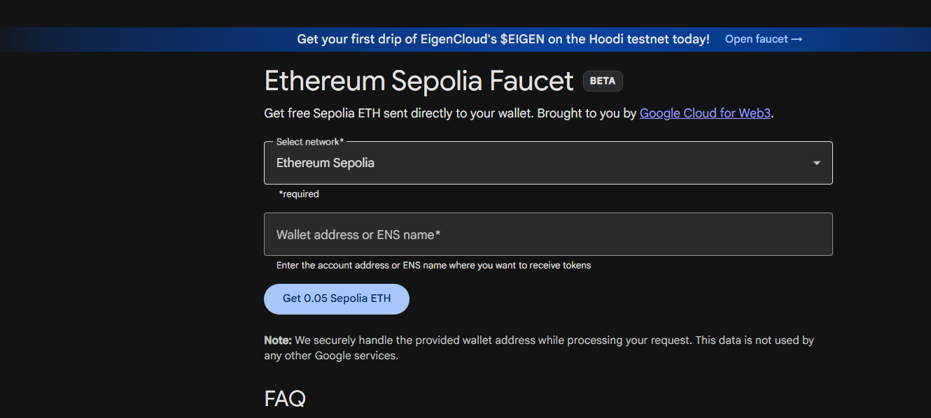
Now copy the wallet address and click on receive sepolia

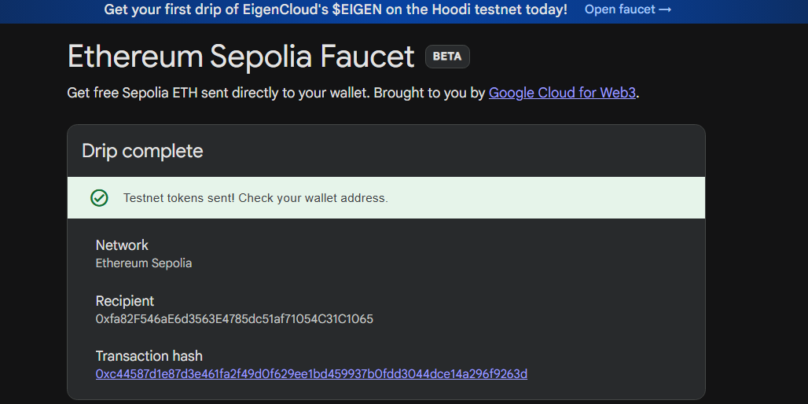

* Implementation Phase: Final Output (no error)
Applied and Action Learning

Now click on send button and paste a another wallet address to send sepolia testnet
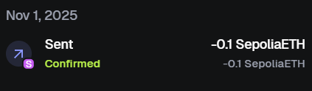
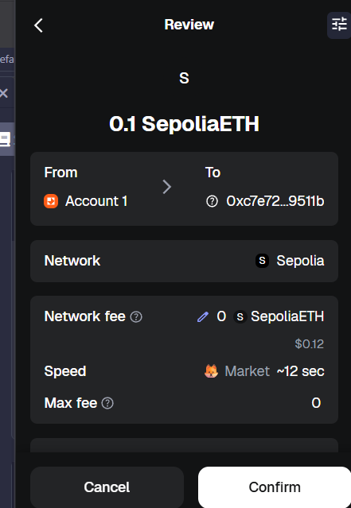

*

Observations
- SepoliaETH was successfully transferred from the sender’s MetaMask wallet to the recipient’s wallet address on the Sepolia Test Network.
- MetaMask displayed transaction details including amount sent, recipient address, and gas fee before confirmation.
- The transaction was verified on Sepolia Etherscan, showing status, block number, timestamp, and confirmation count.

Rubrics
Concept | 10
Planning and Execution/  Practical Simulation/ Programming | 10
Result and Interpretation | 10
Record of Applied and Action Learning | 10
Viva | 10
Total | 50


Signature of the Student:
Signature of the Faculty:

